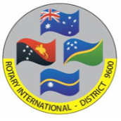

www.rotaryclubofkipparing.com
www.facebook.com/RotaryClubOfKippaRingInc
MEETINGS every WEDNESDAY
6.15pm for 6.30pm START
Rotary District 9600 Office, Evergreen Centre Unit 6 / 14-18 Discovery Drive, North Lakes, Qld

WHAT DO WE DO?
The Rotary Club of Kippa Ring - North Lakes enjoys supporting a wide range of charitable organisations plus local and International projects.

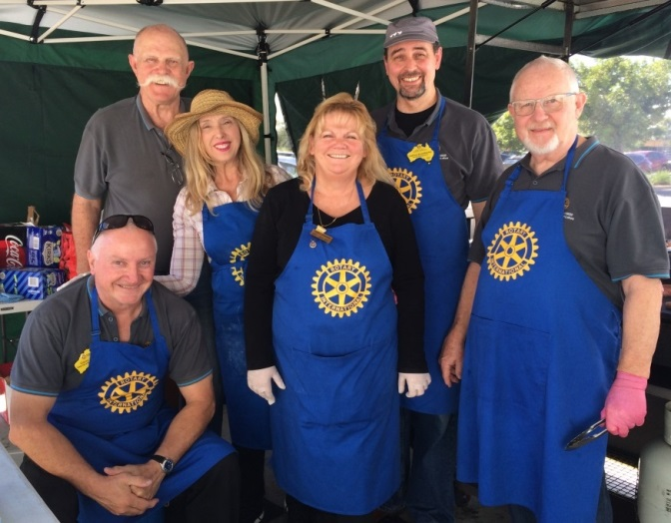
Our Club:
- Actively sponsors young people in a range of youth leadership activities, whilst encouraging and sponsoring and hosting cultural exchange opportunities via Rotary Youth Exchange Program.
- Supports Donations In Kind (DIK) which collects and transports school, medical and educational equipment for distribution to developing nations.
- Proactively supports the global eradication of polio through Rotary’s PolioPlus program.
- Raised funds to ensure the ongoing viability of a Chaplaincy Program at Hercules Road State School.
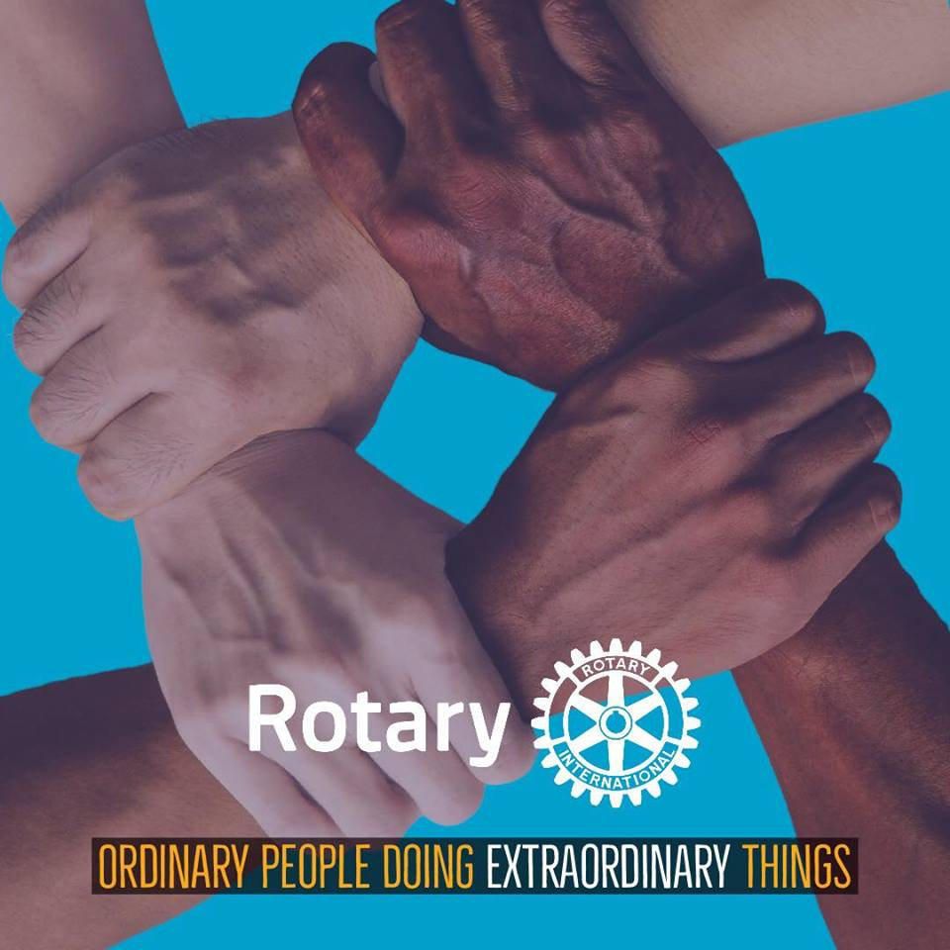
- Supported financially and logistically, local community groups like Chameleon House and Woody Point Special School.
- Promotes our annual Christmas Trailer Raffle which has raised over $480,000 since 1992.
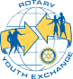
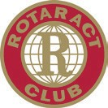
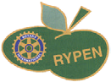
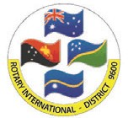

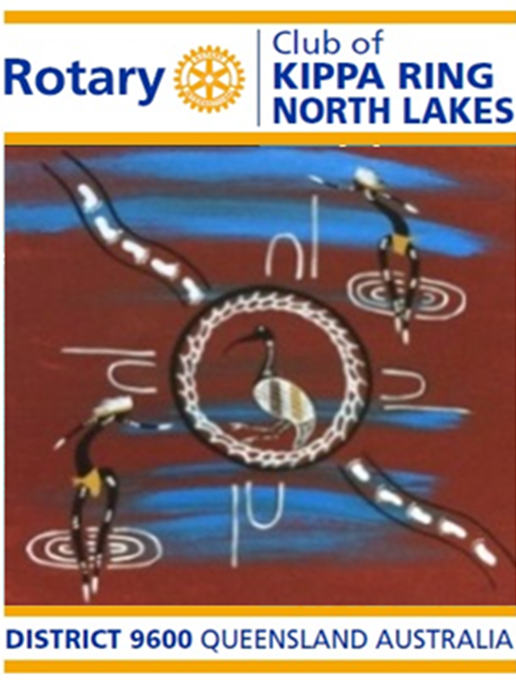

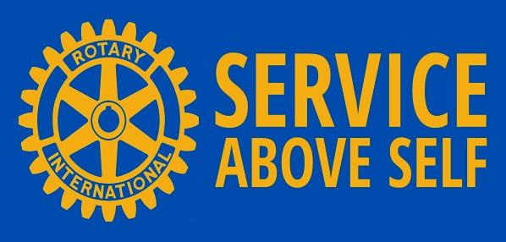

www.rotaryclubofkipparing.com

WHAT IS ROTARY?
Rotary is a global network of 1.22 million community volunteers. Its object is to bring together business and professional leaders in order to provide humanitarian service and to advance goodwill and peace around the world. Some 35,800 Rotary Clubs in more than 220 countries carry out service projects in their local communities and abroad to address such critical issues as poverty, hunger, fresh drinking water, health, illiteracy and environmental concerns.
As a Rotarian, you will be warmly welcomed should you visit any of these clubs. Our club regularly welcomes visitors from around the world.
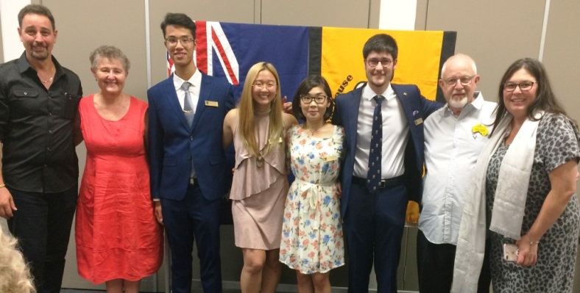

ROTARY PROJECTS
Rotary Clubs participate in a broad range of humanitarian, intercultural, and educational activities designed to improve the human condition. Rotary’s Humanitarian Grants support club projects that provide health care and medical supplies, clean water, food, job training, youth development and education to millions of people in need - particularly in the developing world.
INTERESTED IN ROTARY?
Visitors and potential members are always welcome at the ROTARY CLUB OF KIPPA RING - NORTH LAKES.
For more information, please contact our Secretary at PO BOX 60, MARGATE QLD 4019
Email: rckipparing@gmail.com
www.rotaryclubofkipparing.com

Rotary is dedicated to six areas of focus to build international relationships, improve lives, and create a better world to support our peace efforts and end polio forever.
- PROMOTING PEACE
- FIGHTING DISEASE
- PROVIDING CLEAN WATER, SANITATION AND HYGIENE
- SAVING MOTHERS AND CHILDREN.
- SUPPORTING EDUCATION
- GROWING LOCAL COMMUNITIES.

ROTARY PEOPLE
Belonging to a Rotary Club gives people an enjoyable
and organised way to make a contribution to their
community. Rotary members meet weekly to plan
club, community and international service activities.
By using their skills and expertise globally, Members
also enhance their professional network, career
development and cross-cultural understanding.
Rotary Clubs are non-religious, non-governmental,
and open to every race, culture and creed.
Members represent a cross section of local
business, community and professional leaders.

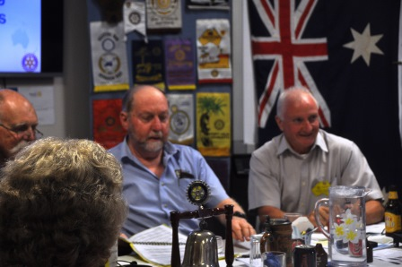
AVENUES OF SERVICE
Rotary clubs worldwide are organised into five
Avenues of Service which form the foundation
of Rotary's work, ensuring focus on Service
Above Self and that service efforts are well
balanced and advance all aspects of the Object
of Rotary to encourage and foster the ideal of
service as a basis of worthy enterprise.
- CLUB SERVICE: focuses on strengthening Fellowship and ensuring the effective functioning of the Club.
- VOCATIONAL SERVICE: encourages Rotarians to serve others through their vocations and to practice high ethical standards.
- COMMUNITY SERVICE: covers the projects and activities the Club undertakes to improve life within its community.
- INTERNATIONAL SERVICE: encompasses actions taken to expand Rotary’s humanitarian reach across the globe and to generate world understanding and peace.
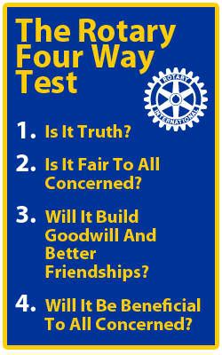
- YOUTH SERVICE: recognises the positive change implemented by youth and young adults through leadership development activities and cultural exchange.

